Фамилия, Имя_____________________________________________

№ школы______________класс_____________
Контактный телефон______________________________________

- Нарисуй несуществующее животное:

one blue body
one pink head
three green eyes
one yellow nose
one red mouth
one long neck
one brown body
five black arms
four white legs

- Соотнеси слова с предметами на картинке:

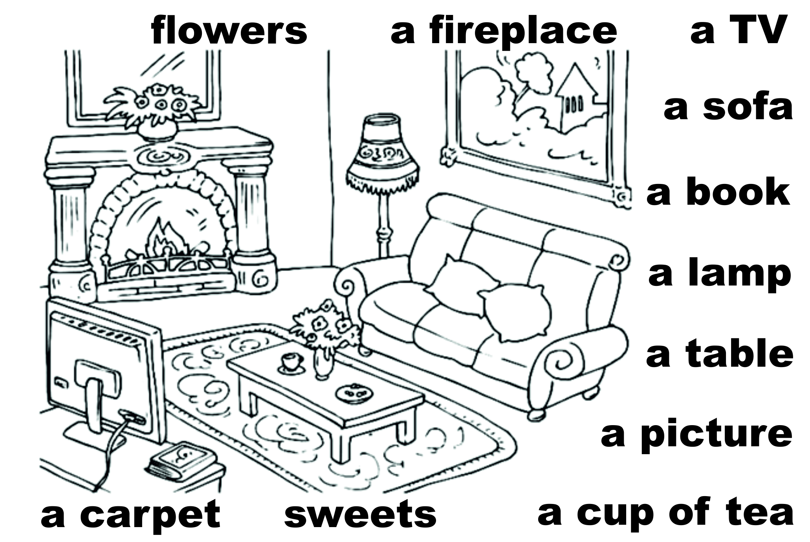

- How are you?

O - I am 10 years old
О - I am a student
О - I am fine, thank you

- _______ old are you? О - Why? О - What? О - How?

- My sister ____ a teacher. О - is О -are О –be
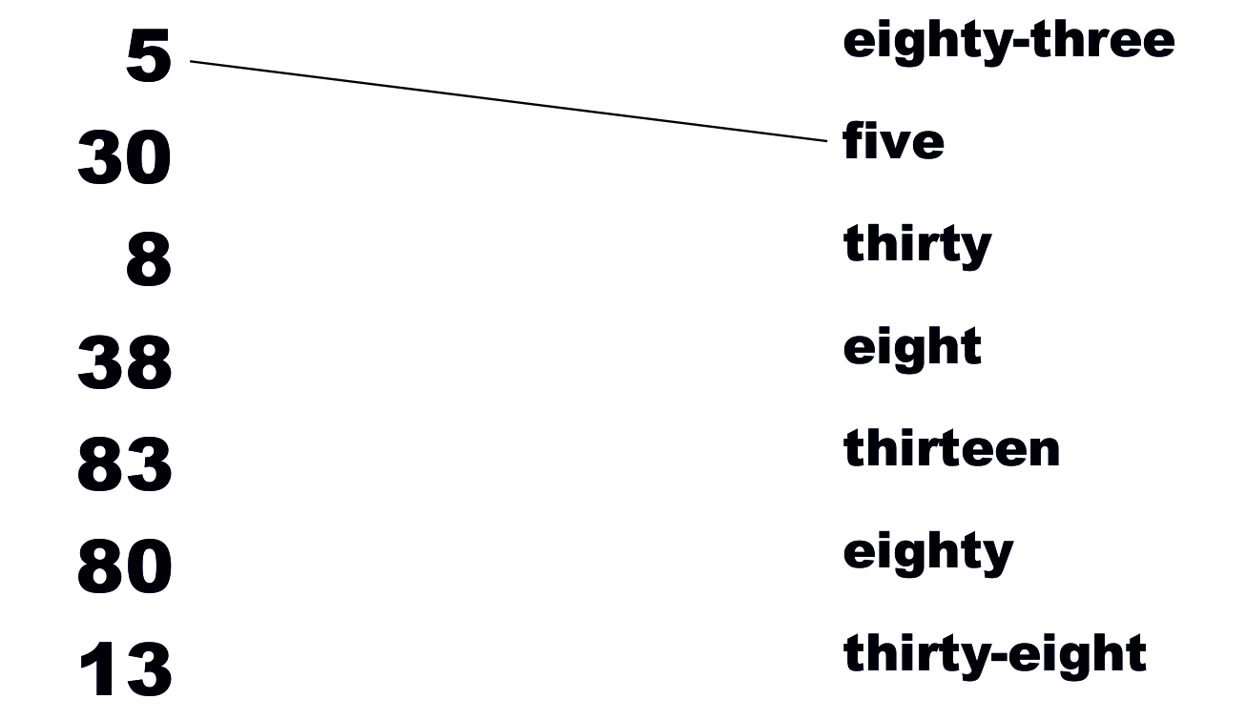
- Соотнеси цифры и числа

7. I can't fly, but I _______ jump.
О - can't О - would О - can

- Укажите имя существительное, имеющее неправильную
форму множественного числа.
О -a son О -a boy О -a gentleman

9. I______to work tomorrow. О -must О -can О -have

- When do you study? О -at school О -in the mornings О -in the library

11. What does your mum do?
О -She is feeding the dog. О -She is a doctor. О -Yes, she does.

12. Are you at home? О -No, I'm not О -No, I don't О -No, I can't

13. _____ your mother _____? О -Do, works. О -Does, work О -Does, works

14. I get up ___ 7 o'clock. О -on О -in О -at

15. Who gave you this book, Nick?
О - I bought it. О -For my Birthday. О -My friend was.

16. Найдите неправильный глагол.
О -to play О -to smile О -to have

17. Найдите ошибку в 3 формах глаголов:
-teach-taught-taught
-bring-braught-braught
-have-had-had

18. Yesterday I ______ a bird. О -saw О -sawed О -see

19. What is she doing?
О -Sheis playing with the bunny. О -She is a manager. О -She is clean the carpet.

